AN INTERPLANETARY MISSION TO NEPTUNE SYSTEM: GRAVITATIONAL CAPTURE OF SMALL BODIES BY TRITON

Carlos Renato Huaura Solórzano, Antonio Fernando Bertachini de Almeida Prado

National Institute for Space Research (INPE)
São José Dos Campos-SP-12227-010-Brazil
Phone(55-12)3945-6201-Fax(55-12)3945-6226
renato@dem.inpe.br, prado@dem.inpe.br

ABSTRACT: At the present time we are still working to improve our knowledge of the Solar System. To do this, on July 1st, 2004, the international Cassini-Huygens Mission spacecraft entered into orbit around the planet Saturn. In January 2005, data came from the Huygens probe, which is on Saturn’s largest moon, Titan. On January 19, 2006, occurred the launch of the New Horizons spacecraft to Pluto and Charon. A recent NASA report ranks a mission to Neptune System at the top of the priorities of the NASA's Solar System Exploration Theme. Hammel et al (2002) propose in details the main targets of this mission. Solórzano et al (2004) proposed a mission to Neptune, analyzing several schemes for the trip from Earth to Neptune. In this work, we give the main characteristics of the gravitational capture of a spacecraft by Triton that represents a formulation to obtain savings for the maneuver.

1. INTRODUCTION

The temporary gravitational capture have been studied on several frameworks: restricted three-body problem, elliptic restricted three-body problem, etc. Nevertheless, it was shown (Hopf, 1930; Tanikawa, 1983) that the probability of a permanent capture with a purely gravitational mechanics is zero, because every particle will go arbitrarily close to its initial position in the phase space. As a consequence, some no gravitational scenarios of capture have been proposed. A review of them can be found in Pollack, Burns and Tauber (1979). They also propose a gas drag mechanics to facilitate permanent capture. Heppenheimer and Porco (1977) present a treatment of libration-point capture in the restricted three-body problem. In this work they give a detailed treatment of the effects of primary mass-change and features of an arbitrary postcapture orbit. Carusi and others studied the phenomena of close encounters and temporary captures between Jupiter and minor bodies (Carusi and Pozzi, 1978). Their numerical simulations used a number of fictitious minor bodies, which have heliocentric orbits nearly tangent to Jupiter’s orbit and distance from Jupiter less than its radius of action, so that they are potential temporarily captured objects. The stability and capture regions for retrograde jovicentric satellites are numerically explored and plotted in Hénon’s diagram (Huang and Innanen, 1983). Murison (1989) studied the structure of periodic orbit families in the circular restricted three-body problem that are fractal-like. Successive magnifications of selected regions of the C-x₀ plane reveal that the families of periodic orbits are exceedingly complex and, in some ways, self-similar.

The gravitational capture initially was used to understand the capture of planetary satellites. However, in the 90’s decade, this phenomenon is applied in spacecraft trajectories. Belbruno (1990) and Miller and Belbruno (1991) studied missions in the Earth-Moon system that uses this technique to save fuel during the insertions of the spacecraft in its final orbit around the Moon. Using a parameter defined as the two-body energy due to the planet-particle system, Yamakawa (1992) studied the gravitational capture in the Earth-Moon system.

2. MATHEMATICAL MODEL

The definition used here for gravitational capture is taken from Yamakawa (1992). It is used to analyze the two-body energy due to the planet-particle system. A trajectory that begins with an elliptical orbit around the planet has a negative value for this energy. However, when its sign turns from negative to positive, the trajectory changes from an ellipse to a hyperbola, i.e., the particle escapes from the gravitational domain of the planet. This escape trajectory is also a capture trajectory if the time propagation is reversed. For practical purposes, in this paper, the two-body energy of the spacecraft with respect to Triton is monitored. A quantity called E₂ (Belbruno, 2004), that is twice the total energy of a two-body system, is defined with respect to the closer primary, by:

$E_{2}=V^{2}−2μ/r$ (1)

Where V is the velocity of the spacecraft relative to Triton (the closest body), r is the distance between the spacecraft and Triton, and  is the dimensionless gravitational parameter of Triton. From the value of E₂ it is possible to know if the orbit is elliptical (E₂ < 0), parabolic (E₂ = 0), or hyperbolic (E₂ > 0) with respect to Triton. We have considered the circular restricted three-body problem for the Neptune, Triton, and particle, as our dynamical system. The method consists in integrating the trajectories from initial conditions in the vicinity of Triton until the particle escapes. A negative time step is used, so the escape trajectory is a capture trajectory when the time is stepped forward. The circular restricted three-body problem is not integrable, and its total energy and angular momentum are not conserved. Nevertheless, it has an integral of motion, the Jacobi constant. The value of this constant is used to determine if a trajectory can escape from Triton or not. However, the two-body energy is not constant, because of the perturbation of Neptune. The value of the E₂ along the trajectory gives a clue to which body (Neptune or Triton) exerts the dominant gravitational influence on the particle’s trajectory. Figure 1 shows the geometry of the gravitational capture. The symbols are: rp: pericenter distance, : angle that defines the position of the pericenter, : entrance angle that defines the point where the spacecraft reach the sphere of influence. Clockwise turn is a retrograde capture orbit and counter-clockwise turn is a direct capture trajectory.

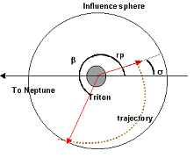 | 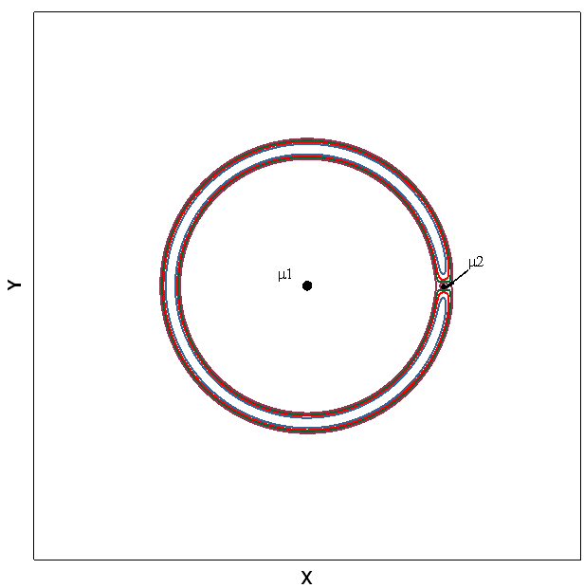
Figure. 1. Geometry of the gravitational capture. | Figure. 2. Zero-velocity curves associate with several values of the Jacobi constant.

3. ANALYSIS

To study the importance of Triton’s influence sphere, we considered several values and analyzed its influence on the gravitational captures. These values are show in Table 1.

Table1. Values for Triton
Condition | Influence Sphere (x10³km) | Radii of Triton (x10³km) | Pericenter Height (x10³km)
I | 80 | 1.353 | 1
II | 100 | 1.353 | 0.1
III | 100 | 1.353 | 0.05

When plotting the values of  vs. C_{J} for several initial values of the two-body energy, we found an exclusion region where the capture is not possible. From the point of view of the zero-velocity curves (Figure 2), there is a neck, where it is possible that the particle is captured by Neptune or escape from the Triton’s influence sphere. Figures 3-5 show several initial values of the two-body energy assumed for the process of gravitational capture. The probability of gravitational capture decreases with the increase in absolute value of the initial energy and with the increase of the value of C_{J}. The gravitational capture perform the imposed conditions that E₂ with respect to Triton is negative in the pericenter and that the distance between Triton and the spacecraft exceeds 10⁵km or 8x10⁴km before completing the 50 days without collision with Triton.

Figure. 3a -  vs. C_{J} for condition I, direct orbits.
Figure. 3b -  vs. C_{J} for condition I, retrograde orbits.

Figure. 4a -  vs. C_{J} for condition II, direct orbits.
Figure. 4b -  vs. C_{J} for condition II, retrograde orbits.

Figure. 5a -  vs. C_{J} for condition III, direct orbits.
Figure. 5b -  vs. C_{J} for condition III, retrograde orbits.

For the condition II and considering that the initial energy is –0.00454 (canonical units), when  is in the interval [0⁰,20⁰] for direct orbits, the time necessary for the capture are between 8 and 13 days. For direct orbits in the interval [60⁰,120⁰] the times are between 5.5 and 8.2 days. For the case of retrograde orbits with  in the interval [0⁰,30⁰] the capture times are between 9.8 and 20 days, however in the interval [120⁰,170⁰] the time are between 12 and 14 days.

4. CONCLUSIONS

In this paper we analyzed the change of the two-body energy of the system particle-Triton, due to the gravitational effects of Neptune. There are several gaps that show a compromise between the angle that defines the position of the pericenter () and the two-body energy (E₂). Nevertheless, our work bring news with respect to the Neptune system. However, due to the perturbation of Neptune, the values of E₂ are high when compared to the values for the Earth-Moon system. Prado (2002) estimated the variations of E₂ as a function of the mass parameter. For the Neptune-Triton-spacecraft system this mass parameter is approximated 10⁻⁴. These disturbing forces are the gravitational force caused by Neptune and the centrifugal force. These forces can reduce the velocity of the spacecraft. This is equivalent of applying continuous propulsion to the spacecraft. The results can be used to prepare missions that goes to the Neptune system with the goal of inserting a spacecraft in Triton.

ACKNOWLEDGMENTS

The authors are grateful to CAPES-Brazil (Coordenação de Aperfeiçoamento de Pessoal de Nível Superior) for the scholarship given to the first author, to the National Council for Scientific and Technological development (CNPq), Brazil, for the research grant receive under Contract 300828/2003-9 and to the Foundation to Support Research in the São Paulo State (FAPESP) for the research grant received under Contract 2006/00187-0.

REFERENCES

- Belbruno, E. A. Examples of the nonlinear dynamics of ballistic capture and escape in the Earth-Moon system. AIAA Paper 90-2896, 1990.
- Belbruno, E. A. Capture dynamics and chaotic motions in celestial mechanics. Book published by Princeton University Press, 2004.
- Carusi, A.; Pozzi, F. Planetary close encounters between Jupiter and about 3000 fictitious minor bodies. Moon. Planets, v. 19, p. 71, 1978.
- Hammel, H. B; et al. Exploration of the Neptune System 2003-2013. The Future of Solar System Exploration, ASP Conference Series. V. 272, 2002.
- Heppenheimer, T. A.; Porco, C. New contributions to the problem of capture. Icarus, v. 30, p. 385-401, 1977.
- Hopf, E. Zwei Sätze über den wahrscheinlichen Verlauf der Bewegungen dynamischer Systeme. Math. Ann, v. 103, p. 710, 1930.
- Huang, T. Y.; Innanen, K. A. The gravitational escape/capture of planetary satellites. The Astronomical Journal, v. 88, n 10, p. 1537-1548, 1983.
- Miller, J. K.; Belbruno, E. A. A method for the construction of a Lunar transfer trajectory using ballistic capture. American Astronautical Society, Paper 91-100, 1991.
- Murison, M. A. The fractal dynamics of satellite capture in the circular restricted three-body problem. The Astronomical Journal, v. 98, n 6, p. 2346-2359, 1989.
- Pollack, J. B.; Burns, J.A.; Tauber, M. E. Gas drag in primordial circumplanetary envelopes - A mechanism for satellite capture, Icarus, v. 37, p. 587, 1979.
- Prado, A.F.B.A. Numerical study and analytical estimation of forces acting in ballistic gravitational capture. Journal of Guidance Control and Dynamics, v. 25, N 2, p. 368-375, 2002.
- Solórzano, C. R.; Sukhanov, A. A.; Prado, A.F.B.A. “Optimization of transfers to Neptune”. Proceeding of 5th International Conference on Mathematical Problems in Engineering and Aerospace Sciences, Timisoara, Romênia, 2004.
- Tanikawa, K. Impossibility of the capture of retrograde satellites in the restricted three-body problem. Cel. Mech, v. 29, p. 367, 1983.
- Yamakawa, H. On Earth-Moon transfer trajectory with gravitational capture. Ph.D. dissertation,. Dept. of Aeronautics, Univ. of Tokyo, Japan, 1992.

