CONSECUTIVE COLLISION ORBIT PROBLEMS
TRANSFER MANEUVERS FROM ONE BODY BACK TO THE SAME BODY

Denilson Paulo Souza dos Santos

Antônio Fernando Bertachini de Almeida Prado

Evandro Marconi Rocco
Divisão de Mecânica Espacial e Controle – INPE
C.P. 515, 12227-310 São José dos Campos - SP, Brasil
denilson@dem.inpe.br; prado@dem.inpe.br; evandro@dem.inpe.br

ABSTRACT

The objective of this work is to study optimal space maneuvers that try to reduce the fuel consumption to make interplanetary missions possible. In this type of maneuver, the spacecraft leaves and comes back to the same body. This is called "Application in Space Maneuvers of the Problem of the Multiple Encounters".
For the dynamics of the problem, it is assumed that the three bodies involved are points of mass and do not suffer external disturbances. The considerations done by Prado and Broucke [1] are extended, and the departure and arrival angles of the spacecraft M₃ can be non-symmetrical.
The topics studied here can be applied in missions that leave and come back to the same body, as a mission that leaves the Earth, researches the interplanetary space and comes back to the Earth. Several consecutive collision orbits were simulated and solutions were shown in new variables for better analysis and visualization of the results.

1. INTRODUCTION

The study and the exploration of the space environment are priorities for the countries that want to develop space technologies.
To plan and to execute maneuvers with artificial satellites that are in orbit around the earth are important tasks in space activities. The literature on this theme is vast and several researchers developed alternatives and solutions for these subjects (Gobetz [2], Goddard [3], Hohmann [4], Marec [5], Prado [6], Prado and Rios-Neto [7] and Rocco [8]), however all of them introduce specific modeling for each approach of the problem. To optimize the consumption of fuel in an orbital maneuver of an artificial satellite is an important goal, because it makes possible a larger number of maneuvers, with a consequent prolongation of the life of the satellite.
Fig. 1 - Multiple Encounters
Q (general case ψ ≠ ψ_{f})
Q (extreme case ψ = ψ_{f})
P
ψ_{o}
ψ_{f}
M₁
M₂
M₃
ψ
x
y
M₂ orbit is circular
M₂ orbit is elliptical
P
Q (extreme case ψ = ψ_{f})
M₁
M₂
M₃
x
y
ψ_{o}
ψ_{f}
M₃
Q (general case ψ ≠ ψ_{f})

2. DESCRIPTION OF THE CONSECUTIVE COLLISION ORBITS PROBLEM

M₁ and M₂ are the two primaries with masses (1 - μ) and μ, respectively. M₂ is in a circular orbit around M₁. The space vehicle M₃ leaves M₂ from a point P (t = ψ₀). It follows a trajectory around M₁ and meets again with M₂ in a point Q (t = ψ_{f}), where ψ₀, ψ_{f} ∈ [0, 2π] and ψ_{f} > ψ₀. The values of ψ₀ and ψ_{f} are not necessarily symmetrical. The problem will be modeled using the dynamics of the two bodies, which means that μ = 0, implying in the reduction of the problem with three bodies to a problem with two bodies. In this way, the equations derived by Kepler can be used to find the solutions. Two impulses will be used in the transfer maneuver. It is assumed that the three bodies involved are mass points and do not suffer external disturbances (fig. 1).
Hénon [9, 10] studied this problem and published results with solutions for the case of circular orbits. Howell [11] published solutions for the elliptic case, where the transfers were symmetrical with respect to the periapsis. Prado e Broucke [12] also published solutions for this problem, in the same situations, using the Lambert method to solve the problem. The results were analyzed and disposed in form of tables and graphs.

3. MATHEMATICAL FORMULATION OF THE CONSECUTIVE COLLISION ORBITS PROBLEM

The Hénon problem [9, 10], formulated as a Lambert problem, can be described as below.
- The position of M₃ is known at t = ψ₀ (point P, initial point of the transfer orbit). The position vector R₁ can be specified as a function of the angle ψ₀, where:
$R_{1}=\frac{a(1−e^{2})}{1+\text{ecos}(ψ_{0})}$ (1)
It is the same value for M₂ and M₃, because at the initial moment (t = ψ₀) M₂ and M₃ occupy the same position.
- The position of M₃ at t = ψ_{f} (point Q, final point of the orbit). The position vector R₂, similar to the item above, is described by the equation:
$R_{2}=\frac{a(1−e^{2})}{1+\text{ecos}(ψ_{f})}$ (2)
- The total transfer time is given by$\text{Δt}=ω\left(ψ_{f}−ψ_{0}\right)$. Remember that the angular velocity of the system (ω) is unit, so ψ can be considered to be the time as well as the angle.
- The total angle Δψ, which the spacecraft must travel to go from P to Q, for the case where the orbits are elliptic, has several possible values. First of all, it is necessary to consider two possible choices for the transfer: the one that uses a direction of the shortest possible angle between P and Q (“short way”) and the one that uses the direction of the longest possible angle between these two points (“long way”). After considering these two choices, it is also necessary to consider the possibilities of multirevolution transfers. In this case, the spacecraft leaves P, makes one or more complete revolutions around M₁, and then it goes to Q. Thus, combining those two factors, the possible values for Δψ are [ψ_{f} - ψ₀ + 2mπ] and [2π - (ψ_{f} - ψ₀) + 2mπ]. There is no upper limit for m, and this problem has an infinite number of solutions, except in the case where the orbit of M₃ is parabolic or hyperbolic, where Δψ has a unique value.

The solution of the Lambert problem is the Keplerian orbit that contains the point P and Q and that requires the given transfer time Δt = Δψ = ψ_{f} - ψ₀ for the spacecraft to travel between these two points. In this paper, we used the Gooding’s Lambert routine to solve the Lambert problem [13].
Possible applications for this maneuver are interplanetary research of the Solar System, a basis for a transportation system between the Earth (M₁) and the Moon (M₂) where no orbit correction is required, etc, (Chobotov [14]).

4. DEVELOPMENT AND RESULTS

The solution of the Lambert problem was searched for a long time. The approach to solve this problem is to establish a group of the nonlinear equations (two body problem) and to begin a process of iterations to find an orbit that satisfies all the requirements. The largest difficulty is to choose the best group of equations and parameters for the iterations, so that it guarantees that the convergence happens in all of the cases.
The presented solutions are in terms of the true anomaly (ν), eccentric anomaly (η), velocity variation (ΔV) and we also show solutions in terms of the semimajor axis (a).
They are defined in the following way:
- If the vehicle passes in the periapsis in ψ = 0:
- $$\underline{ν}=ν$$
- $$\underline{η}=η$$
- If the vehicle passes in the apoapsis in ψ = 0:
  - $$\underline{ν}=ν−π$$
  - $$\underline{η}=η−π$$
Solutions with V < 0.01
e = 0.1 | True  Anomaly  Redefined | Eccentric Anomaly | Variation  of  Velocity
ψ (rad) | ν (rad) | η (rad) | ΔV
-1.003 | 0.99753 | 0.99777 | 0.000649
-1.002 | 0.99835 | 0.99851 | 0.000432
-1.001 | 0.99918 | 0.99926 | 0.000216
0.999 | 1.9992 | 1.9991 | 0.000564
1.999 | 0.99877 | 0.99889 | 0.000915
-0.004 | 0.99509 | 0.99457 | 0.00084
-0.003 | 0.99631 | 0.99592 | 0.000629
-0.002 | 0.99754 | 0.99728 | 0.000419
-0.001 | 0.99877 | 0.99864 | 0.000209

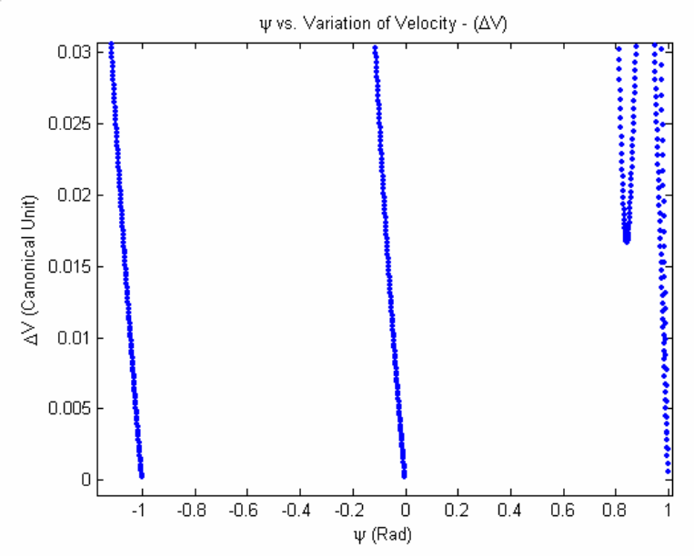
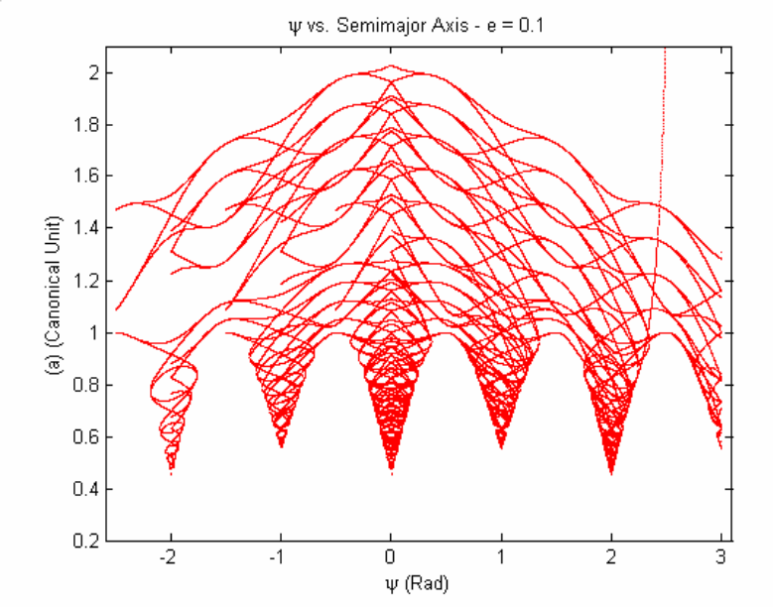
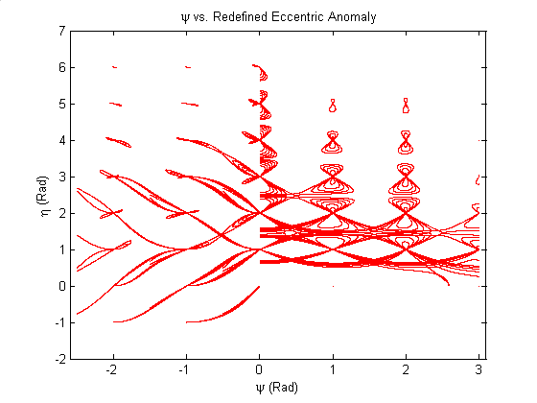
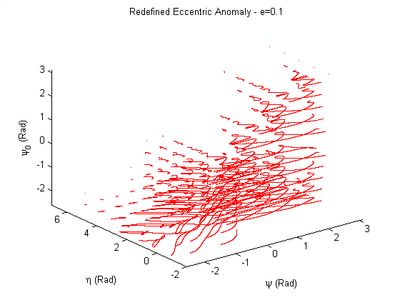
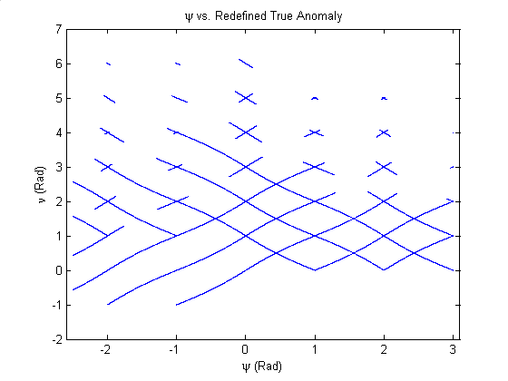
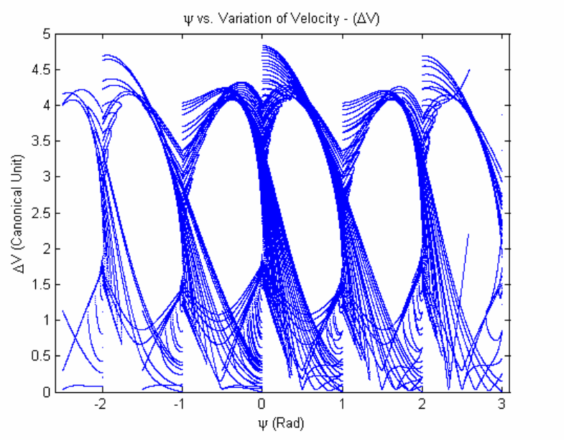
Fig 3 - ΔV Minimum, for e = 0,1

Fig 4 - ψ vs. Semimajor Axis, for e = 0,1

Fig 5 - ψ vs. Redefined Eccentric Anomaly (η), with e = 0,1.

Fig 6 - ψ vs. Redefined Eccentric Anomaly ( η), for e = 0,1, ψ_{o} = - 2,5 e -2,5  ψ  ψ_{f} = 3 rad

Fig 7 - ψ vs. Redefined True Anomaly (ν),
for e = 0,1.

Fig. 2 - ΔV vs. ψ, for e = 0,1, ψ_{o} = - 3 and -2.5  ψ  ψ_{f} = 3 rad.

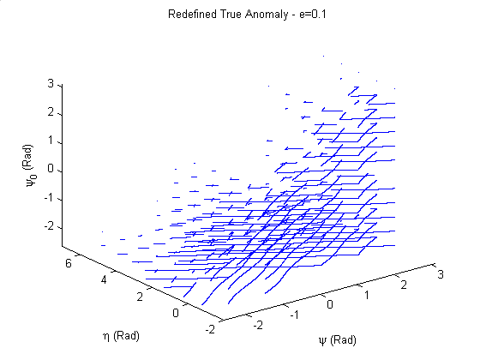
Fig 8 - ψ vs. Redefined True Anomaly (ν), for e = 0,1, ψ_{o} = - 2,5 e
-2,5  ψ  ψ_{f} = 3 rad

5. CONCLUSION

We studied optimal space maneuvers that reduce the fuel consumption for interplanetary missions, in particular in situations where the spacecraft leaves and comes back to the same body, considering non-symmetrical situations. We included a swing-by in a return passage as a form of gain energy. We showed many solutions, including low-cost maneuvers, that can be used for planning of real missions.

6. ACKNOWLEDGEMENTS

The authors are grateful to CAPES-Brazil (Coordenação de Aperfeiçoamento de Pessoal de Nível Superior) for the scholarship given to the first author, to the National Council for Scientific and Technological development (CNPq), Brazil, for the research grant receive under Contract 300828/2003-9 and to the Foundation to Support Research in the São Paulo State (FAPESP) for the research grant received under Contract 2006/00187-0.

7. REFERENCES

- Prado, A. F. B. A. and Broucke R. A.; “Study of Hénon’s Orbit Transfer Problem Using the Lambert Algorithm”, AIAA Journal of Guidance, Control, and Dynamics, vol 17, number 5, 1993, pages 1075-1081.
- Gobetz, F. W. and Doll, J. R., 1969, "A Survey of Impulsive Trajectories," AIAA Journal, Vol. 7, pp. 801-834.
- Goddard, R. H.; “A method of reaching extreme altitudes”. Smithsonian Institute Public Miscelanea Collect, v. 71, n.2, 1919.
- Hohmann, W., 1925, "Die Erreichbarkeit Der Himmelskorper", Oldenbourg, Munique.
- Marec, J.P., "Optimal Space Trajectories," New York, NY, Elsevier, 1979.
- Prado, A. F. B. A., “Transferências de órbitas com aplicações a trajetórias interplanetárias”, Fundamentos de Tecnologias Espaciais, Prado, A. F. B. A. and Kuga, H. K., Editores, pg. 171-197, INPE São José dos Campos – SP, 2001.
- Prado, A.F.B.A. e Rios-Neto, A., "Um Estudo Bibliográfico sobre o Problema de Transferências de Órbitas". Revista Brasileira de Ciências Mecânicas, Vol. XV, No. 1, 1993, pp. 65-78 (INPE-5601-PRE/1816).
- Rocco, E.M., Prado, A.F.B.A., Souza, M.L.O., “Bi-Impulsive Orbital Transfers Between Non-Coplanar Orbits with Time Limit”. Applied Mechanics in the Americas, Vol. 6, 1999, pp. 259-262. Editors: Djenane Pamplona, Charles Steele, Hans I. Weber , Paulo B. Gonçalves, Iwona Jasiuk, Luiz Bevilacqua. ISBN: 85-900726-1-4.
- M. Henon, Bull. Astronom. (serie 3) (1968), 377.
- Hitzl, D.L. and Hénon, M.; “Critical Generating Orbits for Second Species Periodic Solutions of the Restricted Problem”, Celestial Mechanics, vol. 15, 1977 pag. 421-452.
- Howell, K. C.; “Consecutive Collision Orbits in the Limiting case μ=0 of the Elliptic Restricted Problem” Celestial Mechanics, vol. 40, 1987 pag. 393-407.
- Prado, A.F.B.A. e Broucke, R.A., "The Problem of Transfer Orbits from one Body Back to the Same Body". Advances in the Astronautical Sciences, Vol. 82: Space Flight Mechanics, Part II, Editors: Robert G. Melton, Lincoln J. Wood, Roger C. Thompson, Stuart J. Kerridge, pp.1241-1260 (INPE-5599-PRE/1814).
- Gooding, R. H.; “A Procedure for the Solution of Lambert’s Orbital Boundary-Value Problem”, Celestial Mechanics, vol.48, 1990, pp. 145-165.
- Chobotov, V.A.; Orbital Motion – Second Edition. Reston: American Institute of Aeronautics and Astronautics, 1996.

