NUMERICAL STUDY OF THE GRAVITATIONAL CAPTURE IN THE BI-CIRCULAR FOUR-BODY PROBLEM.
Alexandre Lacerda Machuy Francisco¹, Teresinha de Jesus Stuchi², Antonio Fernando Bertachini de Almeida Prado¹
¹National Institute for Space Research (INPE)
São José Dos Campos-SP-12227-010-Brazil
Phone(55-12)3945-6201-Fax(55-12)3945-6226
²Departament of Mathematical Physics, UFRJ, P. O. Box 68528
21945-970. Rio de Janeiro, RJ - Brazil
machuy@dem.inpe.br, tstuchi@if.ufrj.br, prado@dem.inpe.br

ABSTRACT: A gravitational capture occurs when a spacecraft (or any particle with negligible mass) change from a hyperbolic orbit with a small positive energy around a celestial body into an elliptic orbit with a small negative energy without the use of any propulsive system. The force responsible for this modification in the orbit of the spacecraft is the gravitational force of the third and the fourth bodies involved in the dynamics. In this way, those forces are used as a zero cost control, equivalent to a continuous thrust applied in the spacecraft. One of the most important applications of this property is the construction of trajectories to the Moon. The concept of gravitational capture is used, together with the basic ideas of the gravity-assisted maneuver and the bi-elliptic transfer orbit, to generate a trajectory that requires a fuel consumption smaller than the one required by the Hohmann transfer. The goal of the present paper is to study the energy required for the ballistic gravitational capture in a dynamical model that has the presence of four bodies. In particular, the Earth-Moon-Sun-Spacecraft system is considered.

1. INTRODUCTION
The bi-circular problem is a particular case of the problem of four bodies, where one of the masses, let us say $m_{4}$, is supposed to be infinitely smaller than the other three masses. With that hypothesis, $m_{4}$ moves under the gravitational forces of $m_{1}$, $m_{2}$ and $m_{3}$, but it doesn't disturb the motion of the three bodies with significant mass. In the bi-circular problem, the motion of $m_{1}$, $m_{2}$ and $m_{3}$ around the center of mass is considered as formed by circular orbits and the motion of $m_{4}$ has to be a certain function of the initial conditions. We can consider the bi-circular problem as a disturbance of the restricted problem of three bodies. This problem can be used as a model for the motion of a space vehicle in the Sun-Earth-Moon system.
In the first part of the paper we supplied the equations of motion of the model and we defined gravitational capture. The second part is used for the calculation of some numerical results for the bi-circular problem, such as direct orbits, retrograde orbits, capture orbits, etc.

2. MATHEMATICAL MODELS
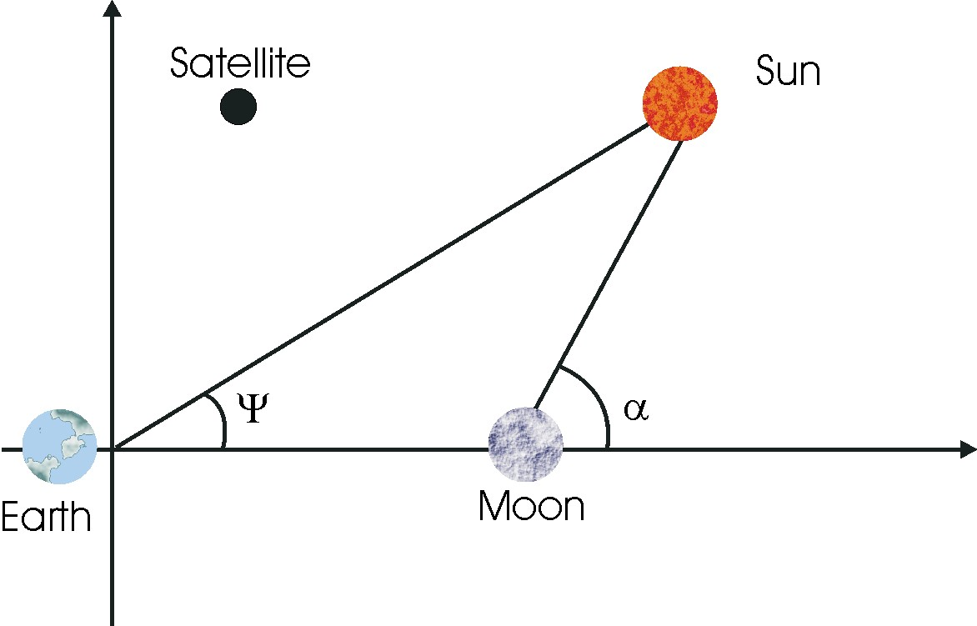
Figure 1 Bi-circular problem.

The problem of four bodies with the two hypotheses shown below is called bi-circular problem and is shown in Fig.1.
First hypothesis: It is considered two bodies with significant mass moving in circular orbits around the mutual center of mass. Those two bodies are called primaries.
Second hypothesis: The third body with significant mass is in a circular orbit around the center of mass of the system formed by the two first primaries and its orbit is coplanar with the orbits of those primaries.
We will study the motion of this fourth body under the gravitational attractions of the three bodies with significant mass.
2.1 Planar equations of motion
We will calculate the planar equations of motion of the space vehicle in the sidereal and synodical systems. We will use the canonical system of units by dividing all the distances by the distance between the two primaries and dividing the masses by the total mass of the two primaries. It will also be defined that the angular speed of the system is unitary. The masses and distances of the Earth, Moon and Sun are: Mass of the Earth, $M_{T}=5\text{.}\text{98}x{\text{10}}^{\text{24}}\text{kg}$; Mass of the Moon, $M_{L}=7\text{.}\text{35}x{\text{10}}^{\text{22}}\text{kg}$; Mass of the Sun, $M_{S}=1\text{.}\text{99}x{\text{10}}^{\text{30}}\text{kg}$. Earth-Moon distance $d_{1}=3\text{.}\text{844}x{\text{10}}^{5}\text{km}$; Earth-Sun distance $d_{2}=1\text{.}\text{496}x{\text{10}}^{8}\text{km}$.
Then, the masses of the Earth, Moon and Sun in the canonical system are:
Mass of the Earth =$μ_{E}=\frac{M_{T}}{M_{L}+M_{T}}=0\text{.}\text{9878715}$; Mass of the Moon =$μ_{M}=\frac{M_{L}}{M_{T}+M_{L}}=0\text{.}\text{0121506683}$; Mass of the Sun $μ_{S}=\frac{M_{S}}{M_{T}+M_{L}}=\text{328900}\text{.}\text{48}$.
The circumferences described by the Moon and the Earth has radius $μ_{E}$ and $μ_{M}$, respectively. $(x,y),(x_{E},y_{E}),(x_{M},y_{M})$ and $(x_{S},y_{S})$ are the coordinates of the space vehicle, the Earth, the Moon and the Sun, respectively. Below are the equations of motion of the Earth, Moon and Sun: $x_{E}=−μ_{M}\text{cos}(t)$,$y_{E}=−μ_{M}\text{sin}(t)$, $x_{M}=μ_{E}\text{cos}(t)$,$y_{M}=μ_{E}\text{sin}(t)$, $x_{S}=R_{S}\text{cos}(ψ)$,$y_{S}=R_{S}\text{sin}(ψ)$ and $ψ=ψ_{0}+ω_{S}t$.
Where $\text{Rs}=\text{389}\text{.}\text{1723985}$ is the distance between the Sun and the center of the system and $ω_{s}=0\text{.}\text{07480133}$ is the angular speed of the Sun. We observed that the positions of the Moon, Earth and Sun are: $(μ_{E},0)$, $(μ_{M},0)$ and $(R_{S}\text{cos}(ψ_{0}),R_{S}\text{sin}(ψ_{0}))$.
The distance of the space vehicle to the Earth is $r_{1}=\sqrt{(x−x)^{2}+(y−y_{E})^{2}}$; to the Moon is $r_{2}=\sqrt{(x−x_{M})^{2}+(y−y)^{2}}$; to the Sun is $r_{3}=\sqrt{(x−x_{S})^{2}+(y−y_{S})^{2}}$.
Therefore, we have the equations of motion of the space vehicle in the inertial system:

$\overset{¨}{x}=−μ_{E}\frac{(x−x_{E})}{r_{1}^{3}}−μ_{M}\frac{(x−x_{M})}{r_{2}^{3}}−μ_{S}\frac{(x−x_{S})}{r_{3}^{3}}$, $(1)$
$\overset{¨}{y}=−μ_{E}\frac{(y−y_{E})}{r_{1}^{3}}−μ_{M}\frac{(y−y_{M})}{r_{2}^{3}}−μ_{S}\frac{(y−y_{S})}{r_{3}^{3}}$. $(2)$

We will introduce a system of rotating coordinates on the center of mass of the Earth-Moon system with the same angular speed of the primaries. Be $(ξ,η)$ the coordinates of the particle in this synodical system. The equations that convert the coordinates of the fixed system to the rotating system are:

$\left(\begin{matrix}x \\ y\end{matrix}\right)=\left(\begin{matrix}\text{cos}(t) & −\text{sin}(t) \\ \text{sin}(t) & \text{cos}(t)\end{matrix}\right)\left(\begin{matrix}ξ \\ η\end{matrix}\right)$ $(3)$

If we now differentiate each component in equation $(3)$ twice we obtain

$\left(\begin{matrix}\overset{˙}{x} \\ \overset{˙}{y}\end{matrix}\right)=\left(\begin{matrix}\text{cos}(t) & −\text{sin}(t) \\ \text{sin}(t) & \text{cos}(t)\end{matrix}\right)\left(\begin{matrix}\overset{˙}{ξ}−η \\ ξ+\overset{˙}{η}\end{matrix}\right)$, and $\left(\begin{matrix}\overset{¨}{x} \\ \overset{¨}{y}\end{matrix}\right)=\left(\begin{matrix}\text{cos}(t) & −\text{sin}(t) \\ \text{sin}(t) & \text{cos}(t)\end{matrix}\right)\left(\begin{matrix}\overset{¨}{ξ}−2\overset{˙}{η}−ξ \\ \overset{¨}{η}+2\overset{˙}{ξ}−η\end{matrix}\right)$ $(4−5)$.
To position of the four bodies are: Moon $(ξ_{M},η_{M})=(μ_{E},0)$, Earth $(ξ_{E},η_{E})=(−μ_{M},0)$, Space Vehicle $(ξ,η)$, Sun $(ξ_{S},η_{S})=(R_{S}[\text{cos}((1−ω_{S})t−ψ_{0})],−R_{S}[\text{sin}((1−ω_{S})t−ψ_{0})])$. It is clear that $1−ω_{S}$ is the angular speed of the Sun in the synodical system. The coordinates $(ξ,η)$ are called synodical and the coordinates $(x,y)$ are called sidereal. The three distances in the synodical system are shown below. From the space vehicle to the Earth is $r_{1}=\sqrt{(ξ+μ_{M})^{2}+η^{2}}$; from the space vehicle to the Moon is $r_{2}=\sqrt{(ξ−μ_{E})^{2}+η^{2}}$ and from the space vehicle to the Sun is $r_{3}=\sqrt{(ξ−ξ_{S})^{2}+(η−η_{S})^{2}}$.
The equations of motion of the space vehicle in the new system are:
$\overset{¨}{ξ}−2\overset{˙}{η}−ξ−\frac{μ_{S}}{R_{S}^{3}}ξ_{S}=−μ_{E}\frac{ξ+μ_{M}}{r_{1}^{3}}−μ_{M}\frac{ξ−μ_{E}}{r_{2}^{3}}−μ_{S}\frac{ξ−ξ_{S}}{r_{3}^{3}}$ $(6)$
$\overset{¨}{η}+2\overset{˙}{ξ}−η+\frac{μ_{S}}{R_{S}^{3}}η_{S}=−μ_{E}\frac{η}{r_{1}^{3}}−μ_{M}\frac{η}{r_{2}^{3}}−μ_{S}\frac{η−η_{S}}{r_{3}^{3}}$ $(7)$

3.0 GRAVITATIONAL CAPTURE

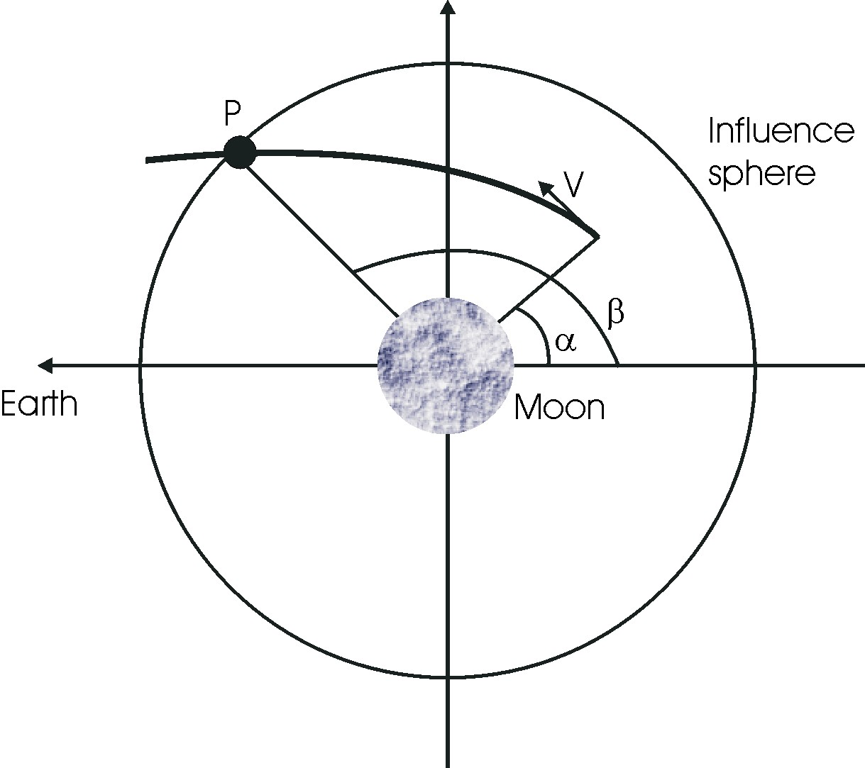
Figure 2 Initial conditions.

Figure 2 shows a trajectory that ends in gravitational capture. To define gravitational capture is necessary to use some basic concepts of the problem of two bodies. We will call $C_{3}$ the double of the sum of the kinetic and potential energy of the problem of two bodies, the space vehicle and Moon, that is given by: $C_{3}=V^{2}−\frac{2μ_{M}}{r}$, where $r$ and $V$ are, respectively, the distance and the velocity of the space vehicle with respect to the Moon, and $μ_{M}$ is the gravitational parameter of the Moon.
If we consider only two bodies (the Moon and the space vehicle), $C_{3}$ is constant, if only gravitational forces are considered. We will describe the orbits of the space vehicle for values of $C_{3}$ according to the classification: $i)$ If $C_{3}>0$, we have hyperbolic orbits, $\text{ii})$ If $C_{3}=0$, we have parabolic orbits, $\text{iii})$ If $C_{3}<0$, we have elliptic orbits.
We defined $C_{3}$ as being of the double of the energy of the system Moon-vehicle. Unlike what happens in the problem of two bodies, $C_{3}$ is not constant in the bi-circular problem. Then, for some initial conditions, the space vehicle can alter the sign of the energy from positive to negative or from negative to positive. When the variation is from positive to negative it is called a gravitational capture orbit. The opposite situation, when the energy changes from negative to positive, is called gravitational escape.
We describe the numeric methodology below.
$1)$ A Runge-Kutta of fourth order integrator was used, programmed in the FORTRAN language.
$2)$ We integrated the equations of motion of the space vehicle in the sidereal system.
$3)$ The initial conditions are obtained in the following way. We consider the Moon in the origin of the $\text{XY}$ system and the Earth with coordinates $(−1,0)$. The starting point of each trajectory is at a distance of 100 km from the surface of the Moon ($r_{p}=\text{1838}$ km, starting from the center of the Moon). To specify the initial position completely it is necessary to know the value of one more variable. The variable used is the angle $α$, that is the position of the Moon. This angle is measured starting from the Earth-moon line, in the counterclockwise sense, starting from the opposite side of the Earth. The magnitude of the initial velocity $V$ is calculated from the initial value of $C_{3}=V^{2}−\frac{2μ_{M}}{r}$. The direction of the velocity vector of the vehicle is chosen as being perpendicular to the line that links the space vehicle to the center of the Moon, appearing in the counterclockwise direction for the direct orbits and in the clockwise direction for the retrograde orbits.
The orbit is considered of capture when the particle reaches the distance of 100000 km (0.26 canonical units) from the center of the moon in a time smaller than 50 days (approximately 12 canonical units). The sphere with radius 100000 km centered in the Moon is defined as the sphere of influence of the Moon. Figure 2 shows the point P, where the space vehicle escapes from the sphere of influence. The angle that defines this point is called the angle of the entrance position and it is described by the Greek letter $β$. During the numeric integration the step of time is negative, therefore the initial conditions are really the final conditions of the orbit after the capture.

4.0 EFFECTS OF THE ANGLE $α$.
We now show some results obtained. Figure 3 shows direct orbits and figure 4 shows retrograde orbits. In both situations the angle $ψ$ is constant and equal to $0^{∘}$, and $C_{3}=−0\text{.}\text{15}$. The angle $α$ assumes the values: ${\text{30}}^{∘}$ (6), ${\text{60}}^{∘}$ (5), ${\text{90}}^{∘}$ (4), ${\text{120}}^{∘}$ (3), ${\text{150}}^{∘}$ (2), ${\text{180}}^{∘}$ (1). The coordinates of the position vector for the case of direct or retrograde orbits are: $x=r_{p}\text{cos}(α)+μ_{E}$ and $y=r_{p}\text{sin}(α)$. The coordinates of the velocity vector for the case of direct orbits are: $x_{v}=−\text{Vsin}(α)$ and $y_{v}=V\text{cos}(α)+μ_{E}$. For the case of retrograde orbits the coordinates of the velocity vector are: $x_{v}=\text{Vsin}(α)$ and $y_{v}=−V\text{cos}(α)+μ_{E}$. We can clearly see the effect of the Sun pushing the trajectories to the right. The direct orbits has a direct path, while the retrograde orbits start their motion to the left and then feel the effects of the Sun and turn to the right.

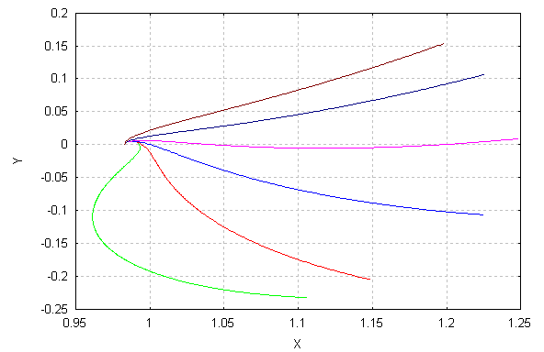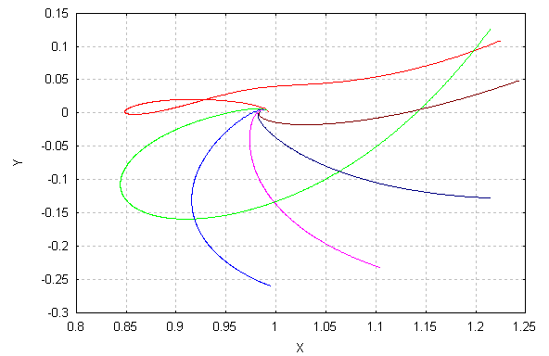
1
2
4
3
5
6
1
2
3
4
5
6
Figure 3 Direct orbits. Figure 4 Retrograde orbits.

5. VARIATION OF THE ENERGY
We now turn our attention to study the effects of the initial value of the energy $C_{3}$. We consider $α=ψ={\text{30}}^{∘}$ and make $C_{3}$ to assume the values -0.1 (1), -0.2 (2), -0.3 (3) and -0.4 (4). In figure 5 we have direct orbits and in figure 6 we have retrograde orbits. We see that the reduction of the energy increase the length of the trajectories and, in some cases, it includes loops. Trajectories with energy close to zero escape faster from the primary.

6. VARIATION OF THE ANGLE $ψ$
We now study the effects of the position of the Sun. We considered $α={\text{90}}^{∘}$ and $C_{3}=−0\text{.}3$ in figures 7 and 8. The angle $ψ$ will assume the values $0^{∘}$ (5), ${\text{30}}^{∘}$ (4), ${\text{45}}^{∘}$ (3), ${\text{60}}^{∘}$ (2) and ${\text{90}}^{∘}$ (1). In figure 7 we have direct orbits and in figure 8 we have retrograde orbits. It is clear that Sun attracts the trajectories. The results show this fact. The retrograde trajectories have this characteristic more visible.

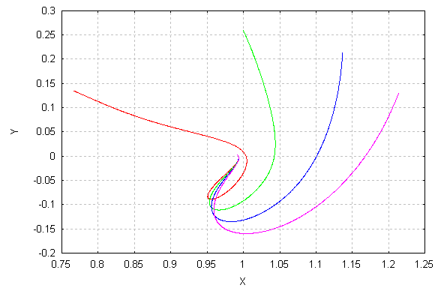
1
2
3
4
1
2
3
4
5
6
Figure 5 Direct trajectories varying $C_{3}$. Figure 6 Retrograde trajectories varying $C_{3}$.

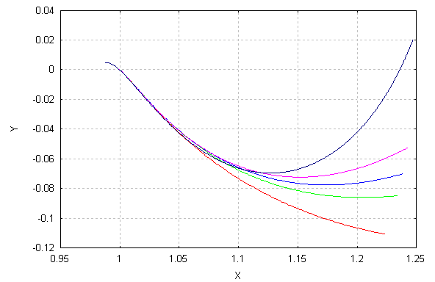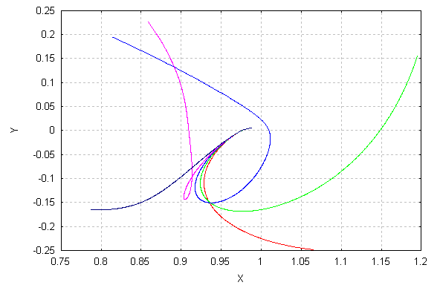
1
2
5
4
3
5
4
3
2
1
Figure 7 Direct orbits. Figure 8 Retrograde orbits.

7. MINIMUM VALUE OF $C_{3}$
The goal now is to calculate the smallest value of the energy that allows a gravitational capture. It will be made a variation of the angle $α$ from $0^{∘}$ up to ${\text{360}}^{∘}$, in steps of $1^{∘}$. Figures 9 and 10 show the results. The initial value of $C_{3}$ is of -0.65, and the final value is -0.01, with variations of -0.01. In figure 9 we have the angles $ψ=0^{∘}$, ${\text{45}}^{∘}$ and ${\text{60}}^{∘}$ and in figure 10 we have the angles $ψ={\text{150}}^{∘}$, ${\text{180}}^{∘}$, ${\text{225}}^{∘}$ and ${\text{270}}^{∘}$. The results show sinusoidal oscillations with strong variations. It shows several points of maximum and minimum savings and it is very important to take into account the initial conditions to obtain good results for the maneuver.
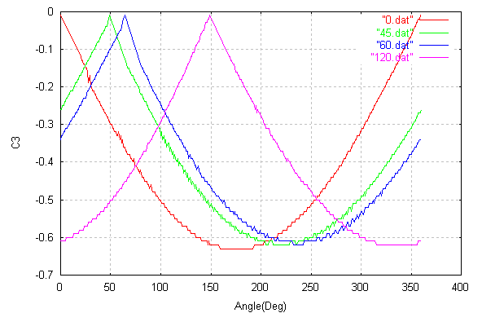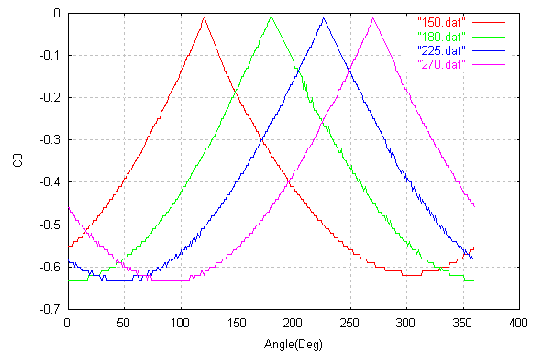
Figure 9 Minimum $C_{3}$ Figure 10 Minimum $C_{3}$

8. CONCLUSONS
This paper studied the problem of gravitational capture under the bi-circular four-body problem. The approach is to perform numerical simulations, in order to know the main characteristics of the problem. In particular, the effects of the initial position and the energy of the spacecraft is considered, as well as the position of the Sun. The results shown here can be to help mission designers to get the most of the gravitational forces involved in the problem.

ACKNOWLEDGMENTS
The authors are grateful to CAPES-Brazil (Coordenação de Aperfeiçoamento de Pessoal de Nível Superior) for the scholarship given to the first author, to the National Council for Scientific and Technological development (CNPq), Brazil, for the research grant receive under Contract 300828/2003-9 and to the Foundation to Support Research in the São Paulo State (FAPESP) for the research grant received under Contract 2006/00187-0.

REFERENCES.
1.Vieira Neto, E. Estudo Numérico da Captura Gravitacional Temporária Utilizando o Problema Restrito de Três Corpos. Ph.D. Dissertation, Instituto Nacional de Pesquisas Espaciais, Brazil, 1999.
2.Prado, A F B A. Numerical study and analytic estimation of forces acting in ballistic gravitational capture. Journal of Guidance, Control and Dynamics 25 (2) 368-375, 2002.
3.Simo, C. Gomez, G., Jorba, A., Masdemont, J. The bi-circular model near the triangular libration points of the R T B P. In: Roy, A. E., Steves, B.A.(Eds.), From Newton to Chaos. Plenum Press, New York, pp. 3453-370, 1995.
4.Castella, E., Jorba, A. On the vertical families of two-dimensional tori near the triangular points of the bi-circular problem. Celestial Mechanics and Dynamical Astronomy 76 (1), 35-54, 2000.
5.Yamakava, H. On Earth-Moon transfer trajectory with gravitational capture. Ph.D. Dissertation, University of Tokyo,1992.
6.Belbruno, E. A., Miller, J.K. Sun-perturbed Earth-to-Moon transfers with ballistic capture. Journal of Guidance, Control and Dynamics 16(4),770-775,1993.

